Application Form for Levy Payer Parking Pass
£8.00 each - 1st June 2026 to 31st May 2027

Concessionary passes are available to residents of Malvern and Parishes who pay the Levy to the Malvern Hills Trust via their Council Tax.

Up to 3 passes can be purchased for vehicles registered to the levy address.

Proof of eligibility
To avoid disappointment these are the ONLY two documents we will accept.

- Copy of the vehicle registration document (V5C) (front page only)
must be produced each time a pass is requested or renewed.
Lease Car, Company Car and Motability car owners will need to provide documentation from the company to prove that the car belongs to you and is registered to you at your Malvern address and is not a pool car

AND

- Current Council Tax Bill
(we do not accept voting cards, utility bills, pension or bank statements).

By Email: Complete this application form with your proof of eligibility as detailed above to parking@malvernhills.org.uk

By Post: Complete this application form and send it with copies of the above documents to Malvern Hills Trust, Manor House, Grange Road, Malvern WR14 3EY including a stamped addressed envelope or add an additional £2.00 for postage. Cheques should be made payable to Malvern Hills Trust.

Bank transfer payment: Quoting your surname and the first vehicle registration number as the reference. Please make payment at the same time you submit your application.

Please use the following bank details: Malvern Hills Trust

Sort Code: 30-95-41 Account number: 01728306

Thank you for your support. Please bear with us as we manage what is likely to be a very high number of requests for passes. We will aim to process all applications within 14 days but cannot guarantee this.

Replacement or Lost passes: Please see information on our website Parking Malvern Hills Trust

Data Protection
The personal information provided on this form will be securely held and is subject to the provisions of the General Data Protection Regulations. The information, which will only be used to record your purchase and contact you in the event of any queries with your application, is confidential and will not be passed on to any other person or organisation. For further information on Malvern Hills Trust’s privacy policy please see the website www.malvernhills.org.uk

Name (block capitals): _______

Email address / or Tel No: ________________________________________________________
(In case of queries)

Levy Payer Parking Pass 1st June 2026 to 31st May 2027
Total pass cost @ £8.00 each pass
e.g. 2 passes £16.00 or 3 passes £24.00
Add £2.00 for postage | £2.00
Total paid by bank transfer
Total pass cost + £2.00 postage
Payment reference
Your surname and 1st vehicle registration
e.g. SmithAA11AAA
Application and Payment date

Please attach a scan or photograph of the following as proof of your address:

- Vehicle registration document (V5C) for EACH vehicle requested (front page only)  AND | 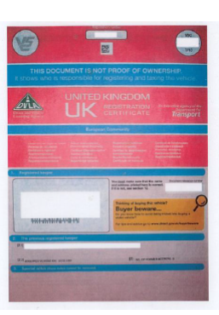
- Current Council Tax Bill | 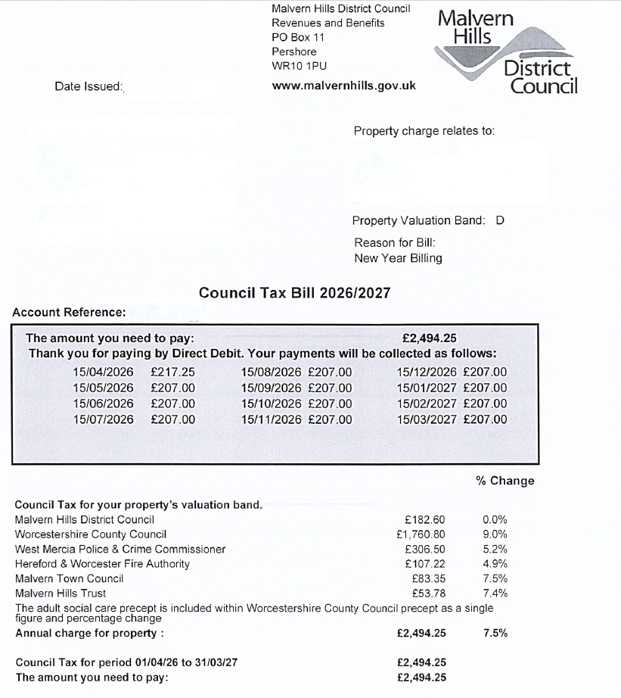

Please note failure to include the correct paperwork and payment
will result in a delay to the process of issuing passes.

